FSDI 105 – Assignment 2
Name: Charles Taggart
Theme: Dark Mode
GitHub Pages Link: https://github.com/chucktagg83/project104.git

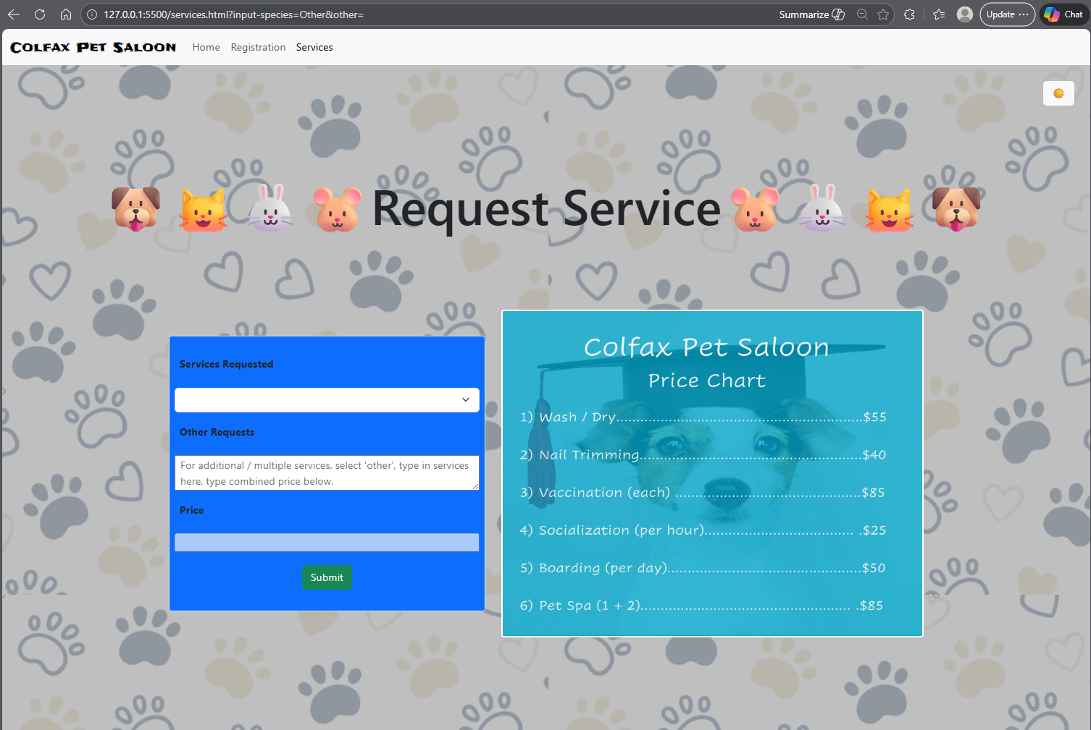
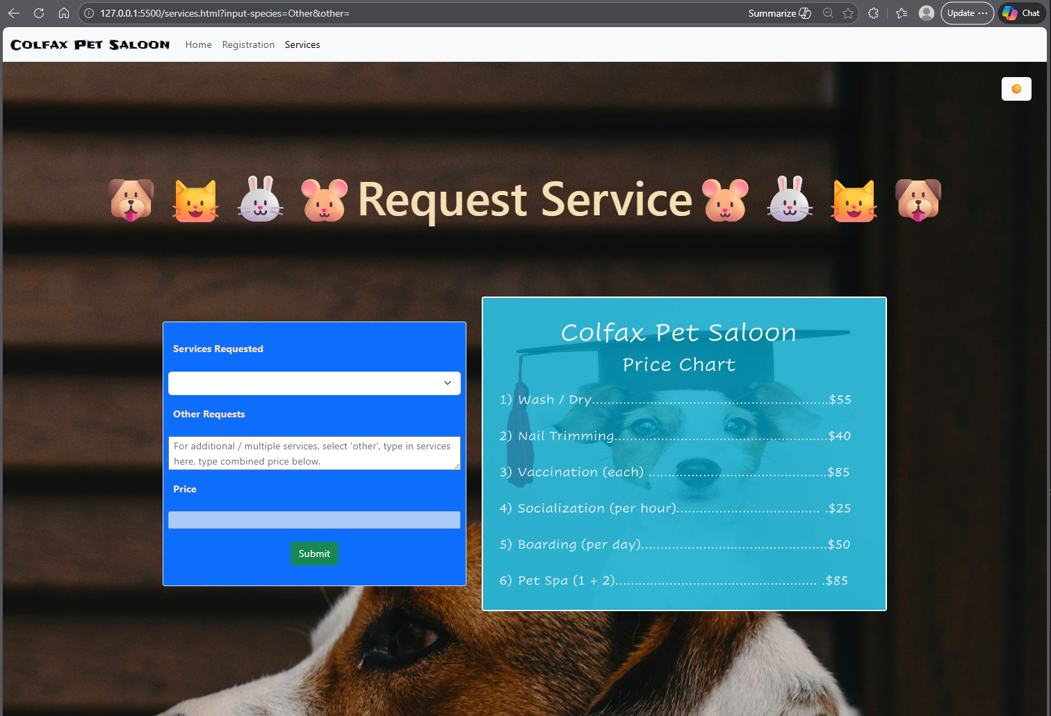
Summary of Edits:
- Implemented toggle button in top right corner to switch from light/dark mode.
- Added in new background image to support dark mode.
- Set light colored text to support transition to dark mode.

